# Lesson 20 – From B4J to B4A

* Transfer a B4J project to B4A

What students should know

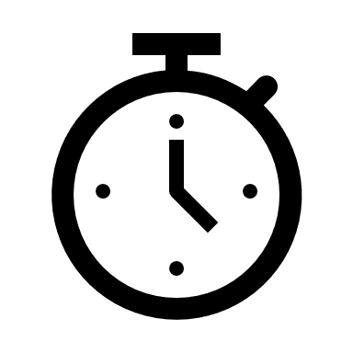**2**

## Congratulations!

Having completed the course’s lessons up to this point you can say that you have acquired a good knowledge of the B4X language. What you've learned so far it is only the beginning of the journey of the "art" of programming.

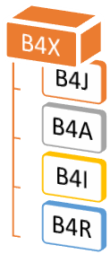

Picture B4X Languages

In addition, the B4X language as discussed in previous chapters can be used to build mobile applications on both Android and IOS. With minimal changes and without having to learn new commands you can transfer an application written in Windows with B4J to Android and the B4A language.

In this last chapter you will deal with the conversion of a program (given ready) into a program for Android.

## Application description in B4J

Picture Simple Calculator

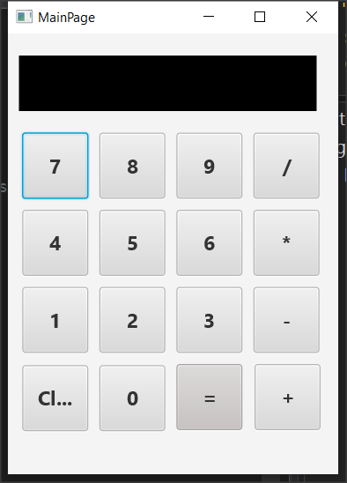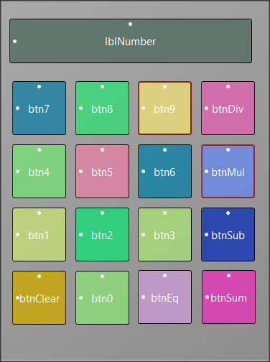

The application is a simple calculator that performs basic operations.

### Designer

The app consists of 16 different buttons and a label that displays the numbers.

Ten of the buttons are the numbers from 0 to 9 and the rest are the basic operations, equality and clear.

In programs where you need to manage multiple buttons, in order not to use separate events for each event_click , it is possible to group the events_click.

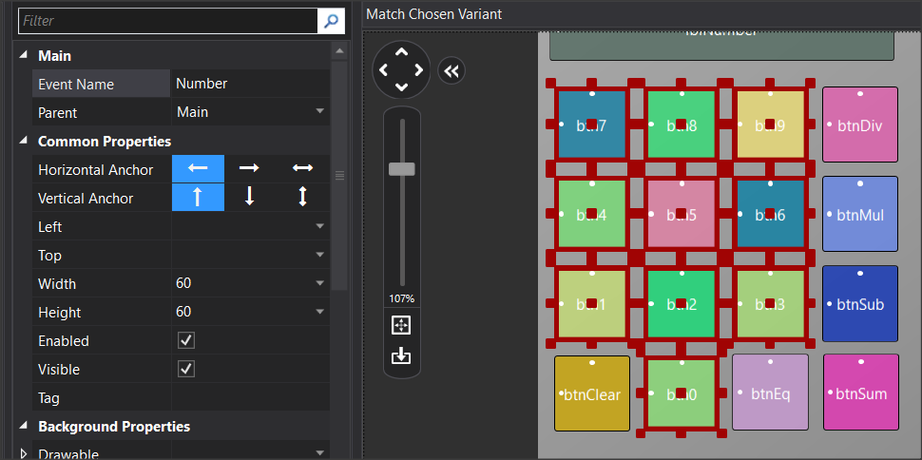

For example, after selecting all the buttons listed in the numbers from 0 to 9, then set the “Event Name” properties, for example Number. Now all buttons have a common click event named Number_Click.

**Private Sub** Number_Click

**Dim** b **As Button**

b = Sender

**Log**(b.Tag)

**If** done  **Then**

lblNumber.Text = 0

done = False

**End If**

lblNumber. **Text** = lblNumber. **Text** & b.Tag

**End Sub**

Also, for you to have a different value from each button you need to update the "tag"property. Assign a value to each different number. For example, in btnNumber1, set “tag” to 1, in btnNumber2 set “Tag” to 2 and so on.

Now in the event take advantage of the Tag value to enter a new number.

Sender assigns the clicked button to variable b.

The program code is as follows. Notice that no buttons have been declared as variables:

**Sub** Class_Globals

Private Root **As B4XView**

Private xui **As XUI**

Private lblNumber **As Label**

Private fltNumber1, fltNumber2 **As Float**

Private operation **As String**

Private done **As Boolean** ‘When true an operation just finished

**End Sub**

**Public Sub** Initialize

**End Sub**

**Private Sub** B4XPage_Created (Root1 As **B4XView**)

Root = Root1

Root.**LoadLayout**("MainPage")

lblNumber.**Text** = ""

done = False

**End Sub**

***‘When Number button clicked add to string lblNumber new Number***

***‘from tag***

**Private Sub** Number_Click

Dim b **As Button**

b = **Sender**

**If** done  **Then**

lblNumber.**Text** = 0

done = False

**End If**

lblNumber.**Text** = lblNumber.**Text** & b.Tag

**End Sub**

***‘When Clear Button clicked clear all numbers and operations***

**Private Sub** btnClear_Click

lblNumber.**Text** = 0

fltNumber1 = 0

fltNumber2 = 0

**End Sub**

***‘When an operation button clicked set operation string to tag***

***‘of clicked operation button***

**Private Sub** operation_Click

Dim b **As Button**

b = **Sender**

operation = b.**Tag**

fltNumber1 = lblNumber.**Text**

lblNumber.**Text** = 0

**End Sub**

***‘When button “=” clicked check operation string and do the operation***

**Private Sub** btnEq_Click

fltNumber2 = lblNumber.**Text**

**If** operation = "+" Then

lblNumber.**Text** = fltNumber1 + fltNumber2

**else If** operation = "-" Then

lblNumber.**Text** = fltNumber1 - fltNumber2

**else If** operation = "*" Then

lblNumber.**Text** = fltNumber1 * fltNumber2

**else If** operation = "/" Then

lblNumber.**Text** = fltNumber1 / fltNumber2

**End If**

fltNumber1 = lblNumber.**Text**

done = True

**End Sub**

## Transfer the app to B4A and Android

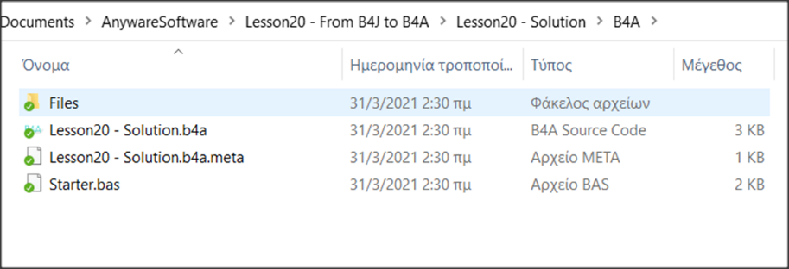Already when you start an application the appropriate folder for B4A and B4i has already been created even though you are not using it yet. These will be inside the relevant Files folder inside the project’s home folder.

To start the transfer, you will need to install the B4A IDE suite. For instructions on installation, see the link <https://www.b4x.com/b4a.html>.

Αfter you complete the installation do not forget to install on your mobile the application **B4A-Bridge** which will help you transfer the calculator to the mobile. The app is free to install from Google Play.

## Transfer of design

Open the calculator with B4J. Similarly open the calculator with B4A. The file of interest is located within the B4A folder and has a b4a extension. Already all the code of the application exists within the B4A!

Open the Designer which visually makes no difference to that of b4j.

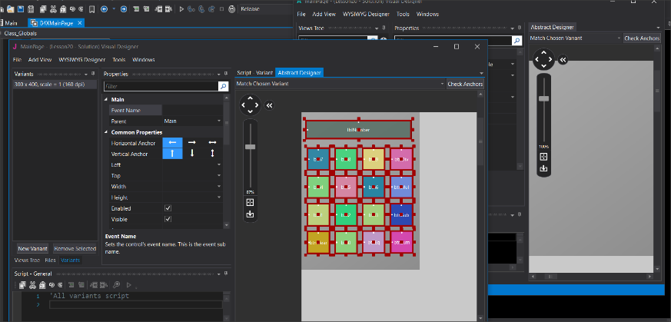The design **has not been transferred** to the B4A but you can easily select all objects from the designer of B4J and by copying and pasting to the design will be added to the B4A project.

You can also make any changes you want to make to the “look” of your app. Finally, save the changes and return to B4A IDE.

## Install an app on your mobile phone.

Before installing the app on a mobile device, you must specify the name of your app and the name of the "package" to be sent to the mobile.

From the tab Main specify the name you want the application to have in the directive #ApplicationLabel:

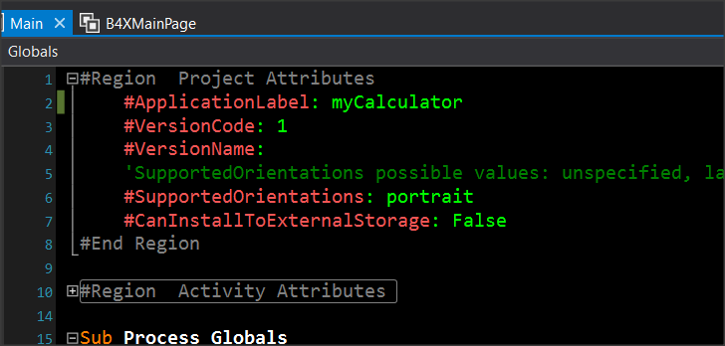

Picture Application Label

It's the name that will appear on the screen of your mobile phone or tablet.

Picture Build Configurations

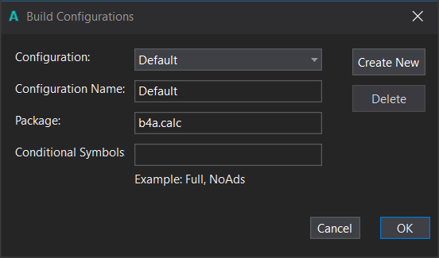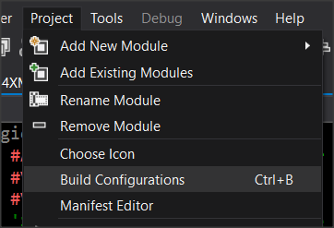

From the Build Configurations menu, specify the name of thePackage:This should be something unique for your device, which is why it is recommended to start with"b4a.". In the example, the package name is "b4a. calc».

Installation on the mobile phone requires that you have already installed the application B4A-Bridge (on the mobile device).

1. Launch the B4A-Bridge app on your Android device and make sure that it's connected to your local network.
2. From the Tools 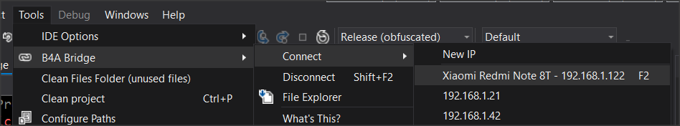 menu -> B4A Bridge -> Connect

Select your device that should appear in the menu. If you can't find it, check to see if it's connected to your local area network.

1. 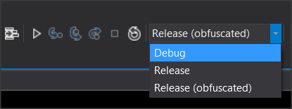Select the type of installation to perform. Debug if you are in the process of debugging the application and Release once you are finished with the deployment and want it to run independently of the development environment of B4A.
2. Tap the run icon and check your phone in B4A-Bridge.

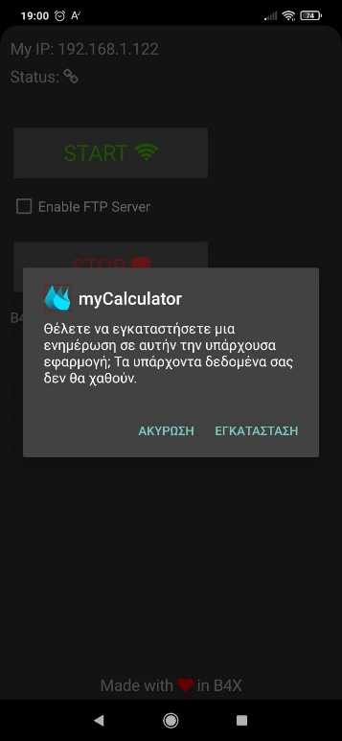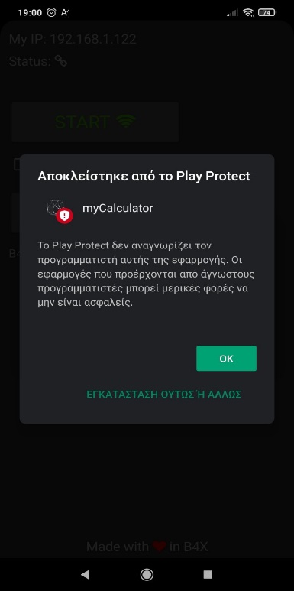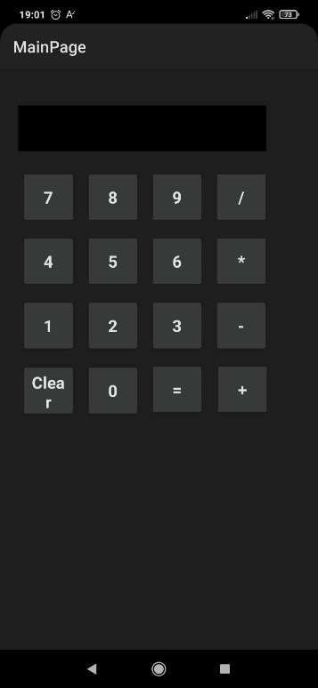

Do you want to install the application?

Cancel Install

Play Protect does not recognize the programmer of this application …

INSTALL ANYWAY

Blocked from Play Protect

During installation, you may receive a message from Play Protect that you can ignore and continue.